
Sweetie News – Holidays 2010

Good Food, Good Deeds Good Lives… by Linda Hundt


It’s the most magical time of the year for everyone at Sweetie-licious! We love all the hustle and bustle; gentle snow flying outside our windows, cheery Christmas music raising spirits, and of course, all the traditional treats that make everyone so holiday-happy here at the shop. Such favorites as; gingerbread boys, frosted Christmas tree cookies, yule logs, chocolate peppermint brownies and cakes and pecan, holiday and apple cranberry pies! Yummy! You know, we have been so fortunate to have Santa come visit the shop to help as much as he has this season. Check out our website to see the video and pictures… SO CUTE! And don’t forget our holiday goodies for all your gift giving!

I’ll be home for Christmas; home. What a beautiful four-letter word. I am not sure there is another word that brings most folks such peace of heart.
I know many of you either have family and friends coming to your homes or you are going back home to yours or theirs, but no matter the circumstance, the yearning for home is universal and timeless.
I am not sure there is anything more poignant than Bing singing, I’ll Be Home For Christmas. As one imagines every G.I. dreaming of their own home, whether it be some life-changing war from yesteryear or today… I believe everyone should be home for Christmas, whether it is realistic or not,
I wish it to be so. Home is the goal, the destination, for there certainly is no place like it. Most importantly, home is where Santa comes every year and still does for us believers. So whether you are traveling to a home or staying at your own, make your home for Christmas, warm and magical with plenty of love, laughter, forgiveness, acceptance, patience, joy and pie!
Eat Pie & Love Life… Linda
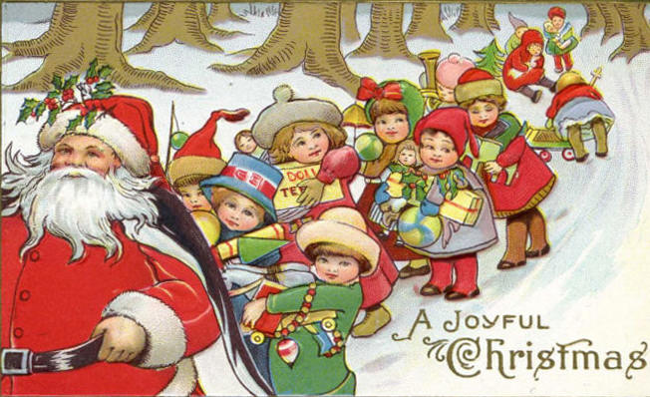
Childlike Faith
Whatever else be lost among the years.
Let us keep Christmas still a shining thing:
Whatever doubts assail us, or what fears,
let us hold close one day, remembering
Its poignant meaning for hearts and men,
Let us get back our childlike faith again.
-- Grace Noll Crowell
”Pie It Forward”
Jeremy Braska volunteers every Tuesday morning at Sweeties as a job experience. He is
a student in Sue Rundborg's classroom at CCRESA. Jeremy's good friend Jason recently hurt his knee and had to have surgery. The following week Jeremy gave Jason his cookie (that he would normally receive as a treat for working). As you can see from the picture, that cookie lifted his spirits! Jeremy is a shining example of
"pie it forward "!
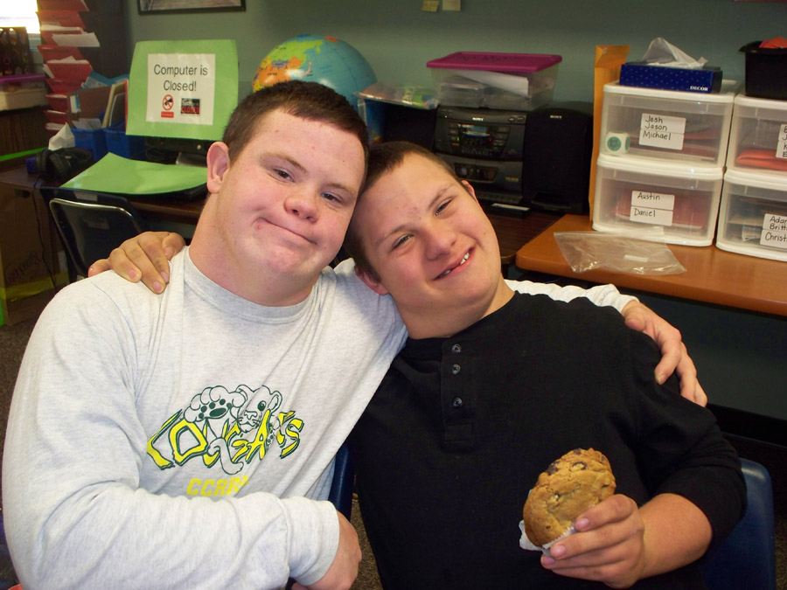
Christmas Cheese Ball

This is such a delicious and festive appetizer and the red green colors make it lovely to serve!

Two softened cream cheese bars (8 oz. each)
2 C. of grated Cracker Barrel white cheddar cheese
1/3 C. dried cranberries, chopped fine
1/3 C. green onions chopped fine
1/8 tsp. of ground allspice
1/4 tsp. of garlic salt or to taste
1/2 tsp. of Worcestershire sauce
1/2 C. of toasted almonds – optional
Few cranks of fresh ground black pepper
1 C. crisp bacon chopped fine
1/4 C. fresh parsley chopped fine
Mix softened cream cheese with electric mixer until blended. Add other ingredients, blend just until well mixed. Form into ball or log. Mix
bacon and parsley together and pat on outside
of cheese ball until covered. Refrigerate.
Sweetie News
Thanks for the wonderful Thanksgiving season again this year, as we had another record breaking year because of all of you! And thanks to all of the hundreds of people across the country who read our article in American Profile and all their lovely thoughts and comments. We have the best fans ever!

A sad farewell to our dear, Tara Curran, who is leaving our Sweetie-licious family to go back to her family back East. Good Luck to Mercedes Cowper and welcome to Sarah Parkinson!
God Bless us Everyone – Merry Christmas and Happy Holidays
May you have the gladness of Christmas which is hope;
The spirit of Christmas which is peace;
The heart of Christmas which is love.
-- Ada V. Hendricks

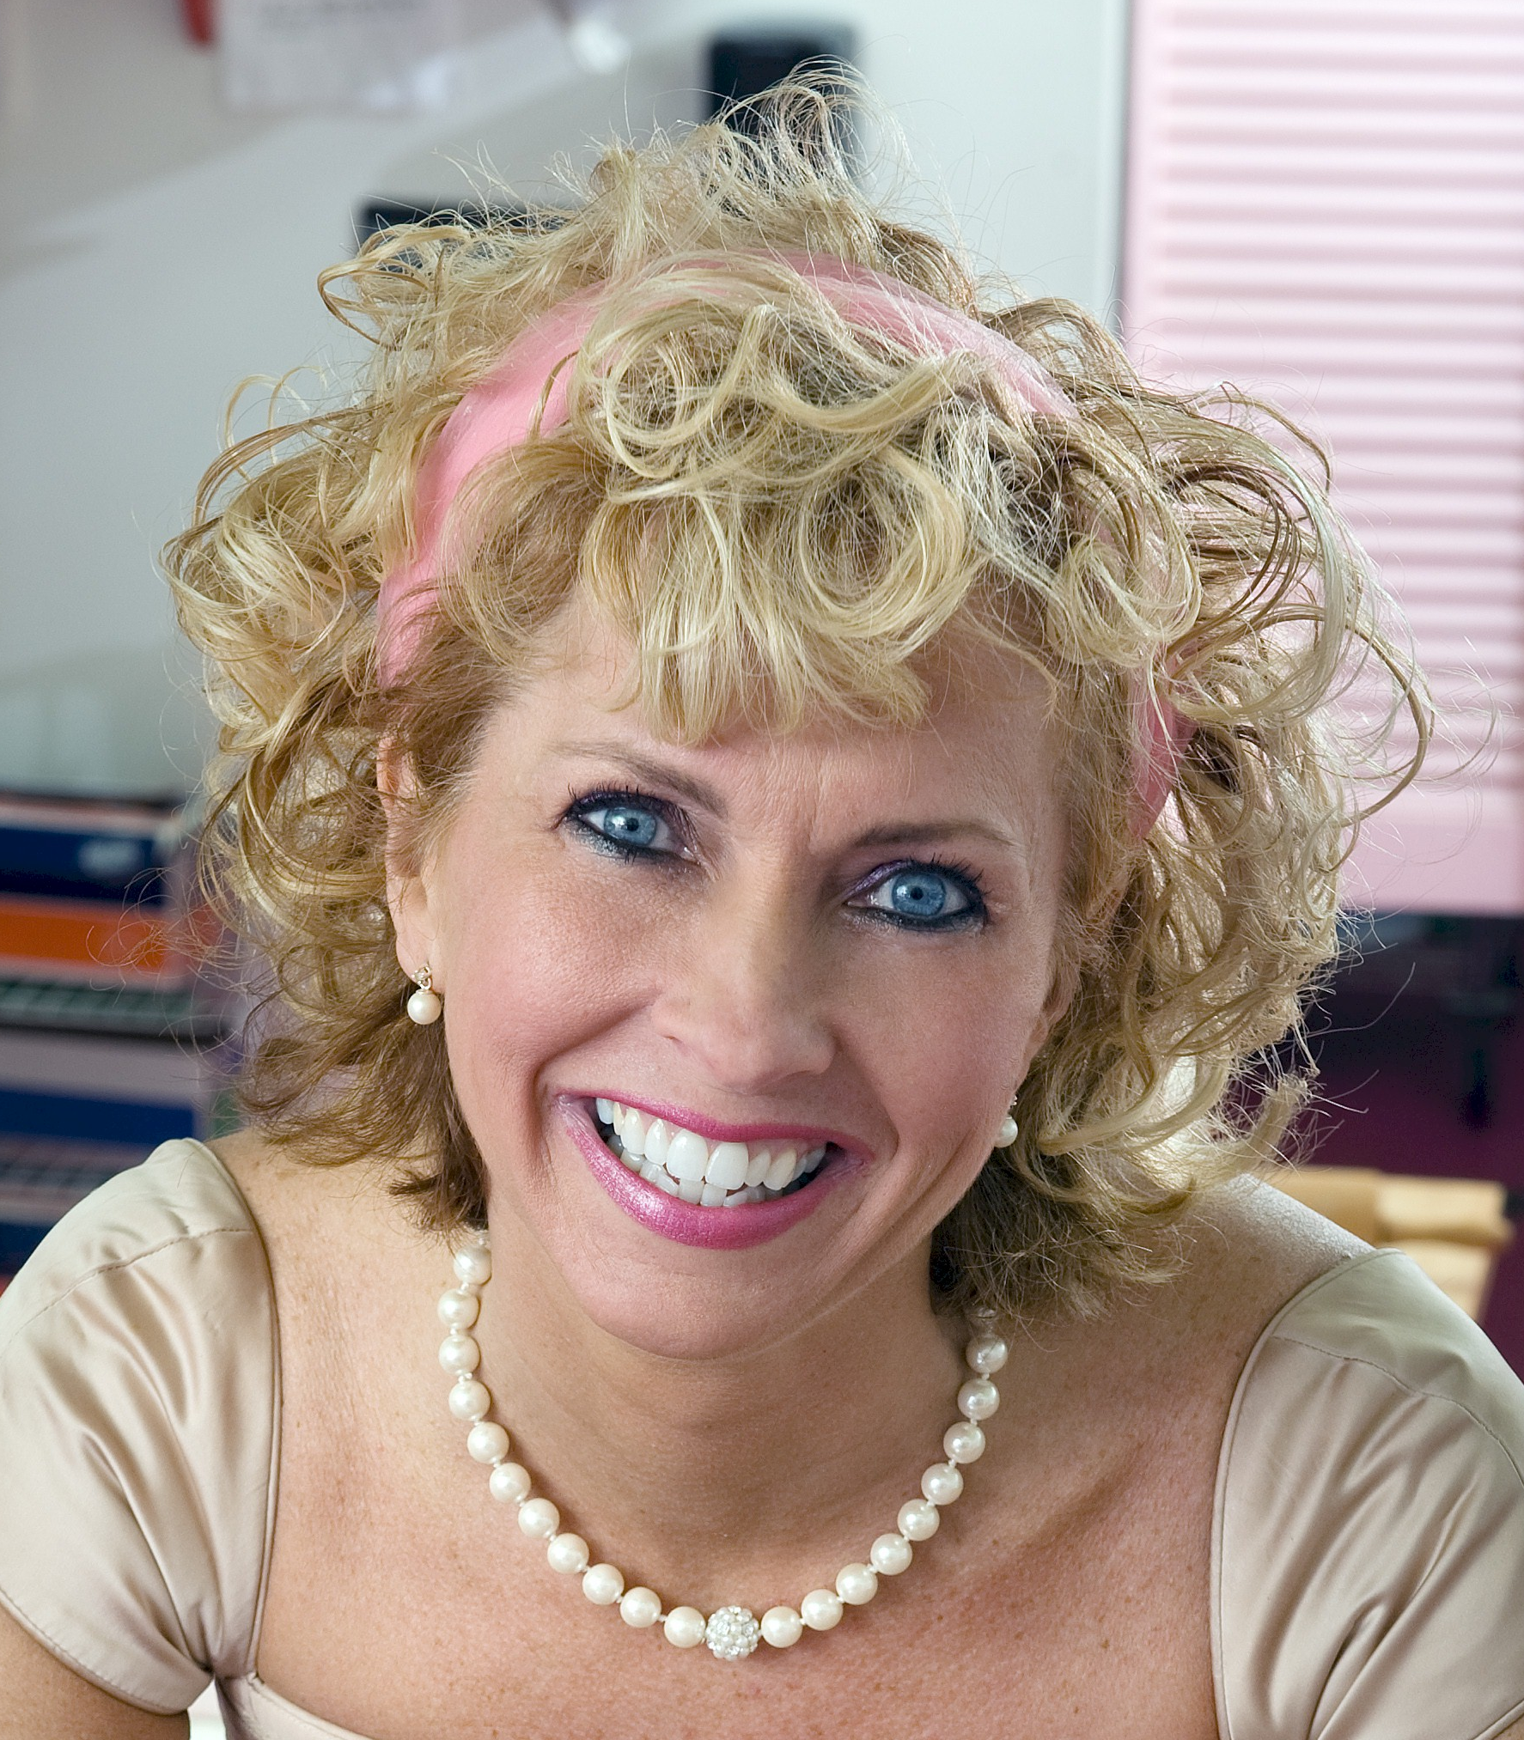
About Linda Hundt …
Linda resides in a century old farmhouse with her sweet husband and two lovely daughters. She is the owner of Sweetie-licious Bakery Cafe in DeWitt MI. She was the grand prize winner in 2009, and a first place winner at the 2010, 2008 & 2007 National Pie Championships. Linda is the co-founder of the Downtown DeWitt Farmers Market, Board Member of the CMU College of Business, Entrepeneurial School, and the 2009 Athena Power-Link recipient.
108 North Bridge St. DeWitt, MI 48820
(517)669-9300 www.sweetie-licious.com

