
Sweetie News – Winter / Valentines Day 2011
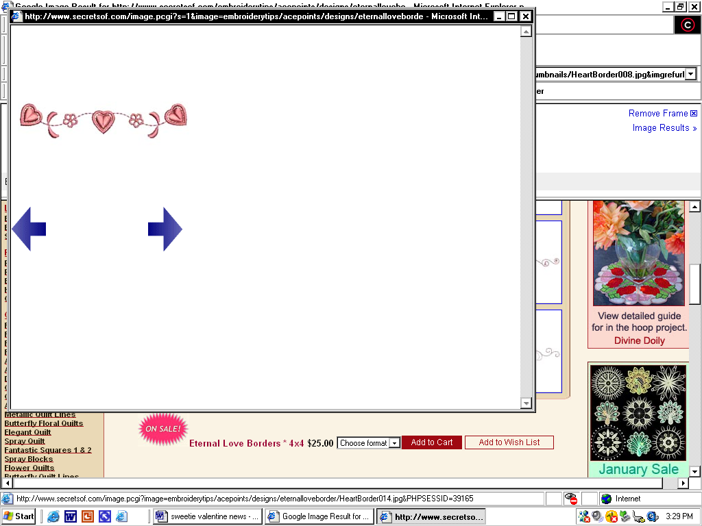
Good Food, Good Deeds Good Lives… by Linda Hundt

Welcome, welcome, welcome to our Sweetie-licious newsletter. Our mission is to celebrate home-life through stories of good food, good deeds, and good lives. Each issue will also present a delicious and simple recipe. I am thrilled to share my treasured library of recipes, stories, and traditions with you all! Here is to making our lives meaningful, our homes happy, and our palates joyous!

What a year for Sweetie-licious in 2010. We are as pleased as punch with our leaps and bounds growth this year and it is all because of you all!
I have always said that we have the best customers and friends. I mean it from the bottom of my happy heart. We have so enjoyed hearing from all of you, whether you are from across the country or across the street – we love that what we are doing makes your tummy &heart full of yummy love!
I have always been a huge advocate of enjoying the seasons, and winter is no exception. Gosh,
what a great time for us to spend time with families, clean closets, go ice skating, make chili, and pie baking.! Enjoy making the delicious soup recipe below to help you “get into” this season with Sweetie-licious flair!
Valentine’s Day - my favorite! Be sure to make the day special for all you love, and if you need help with ultimate sweets for your sweets, we can help you. Please don’t forget to remember those who may be forgotten on this day of love and love them dearly!
So, relish the season, my Sweetie-licious friends!
Eat Pie, Love Life – Linda xoxoxo


O winter, ruler of th’ inverted year,
I crown thee king of intimate delights,
Fireside enjoyments, home-born happiness,
And all comforts that the lowly roof
Of undisturb’d retirement, and the hours
Of long uninterrupted ev’ning, know.
-- William Cowper
Wonderful Wild Rice
Mushroom & Gouda Soup
I love sharing this wonderful Wild Rice Mushroom & Gouda soup recipe. It is very similar to what we make at the shop. To make the meal perfectly yummy, serve with some sweet Michigan apples, crusty French bread, and some aged cheddar cheese (one can never have enough cheese.) Yum!
1 pkg. Uncle Ben’s Wild Rice Quick mix
1 qt. Half and Half
3 C. chicken broth
2 C. gouda cheese – additional cheese for garnish
1 can Campbells Cream of Potato soup
1/2 C. onion chopped fine
2 C. sliced mushrooms - optional
1/3 C. celery, chopped fine
1/2 tsp. minced garlic
1/2 C. white wine
4 Tbsp. butter
1 tsp. fresh rosemary, chopped very fine
4 slices of cooked bacon crumbled – optional
Make rice as directed and set aside. Cook onion, celery, garlic, rosemary & mushrooms in large soup pot with butter on medium heat. Cook until onions, celery are tender and mushrooms are browned. Add wine, and a cup of the half and half. Stir in cheese until melted. Add potato soup, gradually stir in chicken broth until well mixed, remaining half and half and cooked rice. Add pepper to taste. Simmer. Serve with crumbled bacon and additional gouda cheese on top.
News from the Shop
Our big news is our mail order business will be
up and running this winter. This has been a huge strategic endeavor considering our limited space at the shop. We will be shipping to the Midwest and Eastern states first and will expand to Southern states and Western states as time goes on. We will be offering many of our award- winning pies, cookies, muffins, jammies and apparel. Look online soon for more details of our exciting new Sweetie-licious expansion.

Also, soon we will be featuring on our website a series of “How To” videos. We will be sharing some
of our secrets with fans on how to make some
of our wondrous delights. So fun!
Comments from Customers…

What a joy to meet you and enjoy your “pretty pie place”! This year my best friend gifted me with one of your delicious Tom’s pies. When I was young my mother always baked me a cherry pie for my birthday, so the
gift was an especially sentimental one. The pie was remarkable. I ate almost every crumb myself - shared a few bites with friends. I told my friend it was the best birthday gift I had received since 1975 when i got a horse! Blessings to you Linda for the joy you spread. – Donna

Riches takes wings, comforts vanish, hope withers away, but love stays with us.
Love is God.
-- Lew Wallace

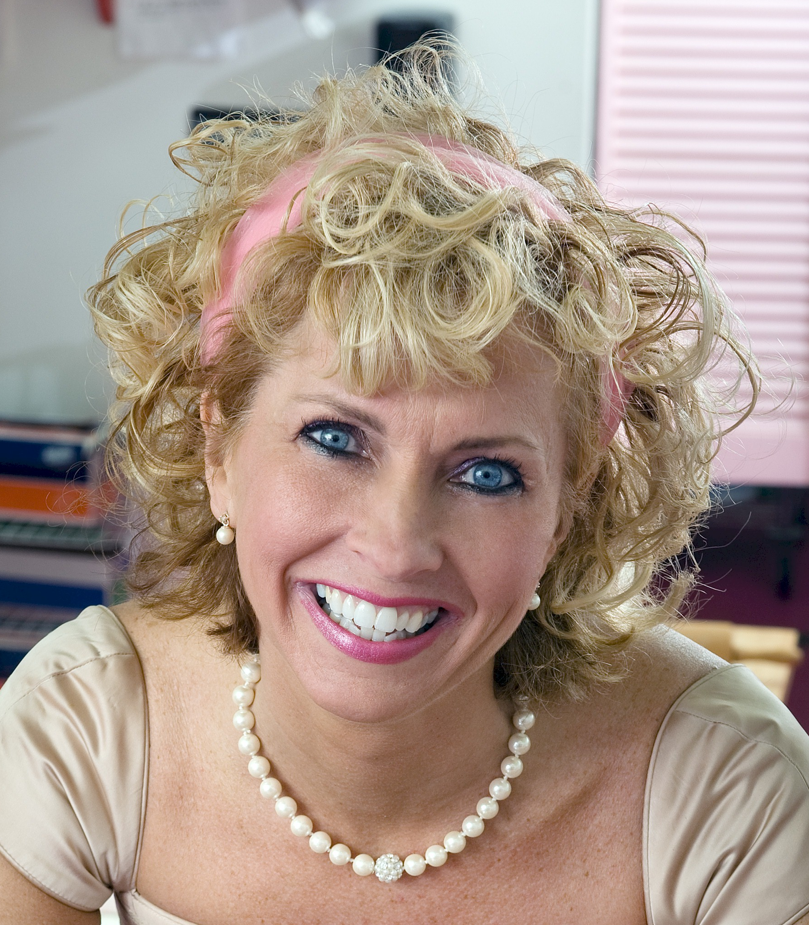
About Linda Hundt …
Linda resides in a century old farmhouse with her sweet husband and two lovely daughters. She is the owner of Sweetie-licious Bakery Cafe in DeWitt MI. She was the grand prize winner in 2009, and a first place winner at the 2010, 2008 & 2007 National Pie Championships. Linda is the co-founder of the Downtown DeWitt Farmers Market, Board Member of the CMU College of Business, Entrepreneurial School, and the 2009 Athena Power-Link recipient.
108 North Bridge St. DeWitt, MI 48820
(517)669-9300 www.sweetie-licious.com

