
Sweetie News – Holidays 2011

Good Food, Good Deeds Good Lives… by Linda Hundt


I love, love, love this time of year. The spirits of the holidays are thick in the air and you can feel it the people, the places, and especially the food. Nothing can compare to the holiday treats and all of the baking wonders that have come out of family kitchens for generations. I know in our family I grew up enveloped with Christmas baking traditions.

My dear grandmother from West Virginia
would send a much-anticipated frozen chocolate pecan pie up to our family every year, and my sweet mother would make various pies, cheesecake, cookies, stained glass hard candy, fudge, and caramels for family and friends to enjoy. I remember my mother would always let me and my brothers and twin sister help make the holiday treats, and for me, this was utopia.
My memories of this time are lovely, and a bit embellished by age.
Most definitely, Christmas cookie decorating
was our family’s favorite baking tradition.
Back in the late sixties and early seventies at Christmas time, I remember our family happily listening to Nat and Bing while snow gently drifted out our tiny, turquoise kitchen window.
I remember my mommy somewhat patiently leading us through another treasured holiday tradition while my daddy read the newspaper
in the living room oblivious to the commotion.
The kitchen was chaotic and crowded with all
five of us kids crammed in, anxious to keep the Christmas cookie decorating tradition alive and well. Every year it was exactly the same, siblings fighting over cookie cutters, cookies decorated quaintly and imperfectly, and kids sneaking cookie dough from our big brown, chipped mixing bowl with joyous giggles echoing throughout our brick home. Despite the cramped space, spats, and mess, the time together as a family was perfect. Not perfect in the real sense of the word, but perfect because we were together and it was our McComb family tradition.
I implore all of you to continue your own family traditions or start new ones, for it is paramount that our traditions continue for our children
as well as their children. For there is nothing better than having the magic in our hearts at Christmas-time as we recall warm, sweet memories of delicious holiday treats, loving family traditions, and Santa Claus!
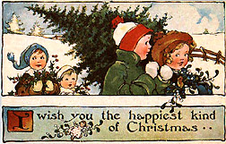
Eat Pie & Love Life… Linda

Santa’s Whiskers
The “whiskers” are shreds of coconut that give these retro favorites their name.
3/4 C. butter
3/4 C. sugar
1 Tbsp. half & half or cream
1 tsp. vanilla
¼ tsp. almond extract
2 C. flour
3/4 C. finely chopped red/green candied cherries
1/3 C. finely chopped pecans
¼ C. shredded coconut

Cream together butter and sugar. Add vanilla, almond extract, and cream. Stir in flour till combined. Add cherries and pecans. Shape into 2 8” rolls. Roll in cococunt. Wrap in plastic wrap and refrigerate for 2-24 hrs. Cut into ¼” slices and place 1” apart on an ungreased cookie sheet. Bake at 375 for 8-10 minutes. Sprinkle with sparkling sugar while warm. Cool on a wire rack.
News from the Shop
We have a bunch of new student employees at
the shop. Are newest “sweeties” are Kenzie Carter, Addy Schaar, Kelly Mackie, Mara Haynie, and Anna Cleary.

On January 16th 2012 Linda will be one of the speakers at the National Retail Federation’s Annual Conference which will be held in New York City. She will be one of two featured speakers talking about business action plans.
The Federation’s conference is one of the largest U.S. retail professional meetings. Last years meeting drew over 22,000 attendees.

After the holidays are over, there is still one day left to celebrate – National Pie Day is January 23rd! We’ll be celebrating at the shop with lots of special treats… so watch Facebook and our Website for more details as the day approaches.

Thanks everyone for a wonderful Thanksgiving season!! We have the best customers ever! God Bless us Everyone – Merry Christmas and Happy Holidays from everyone at Sweetie-licious!
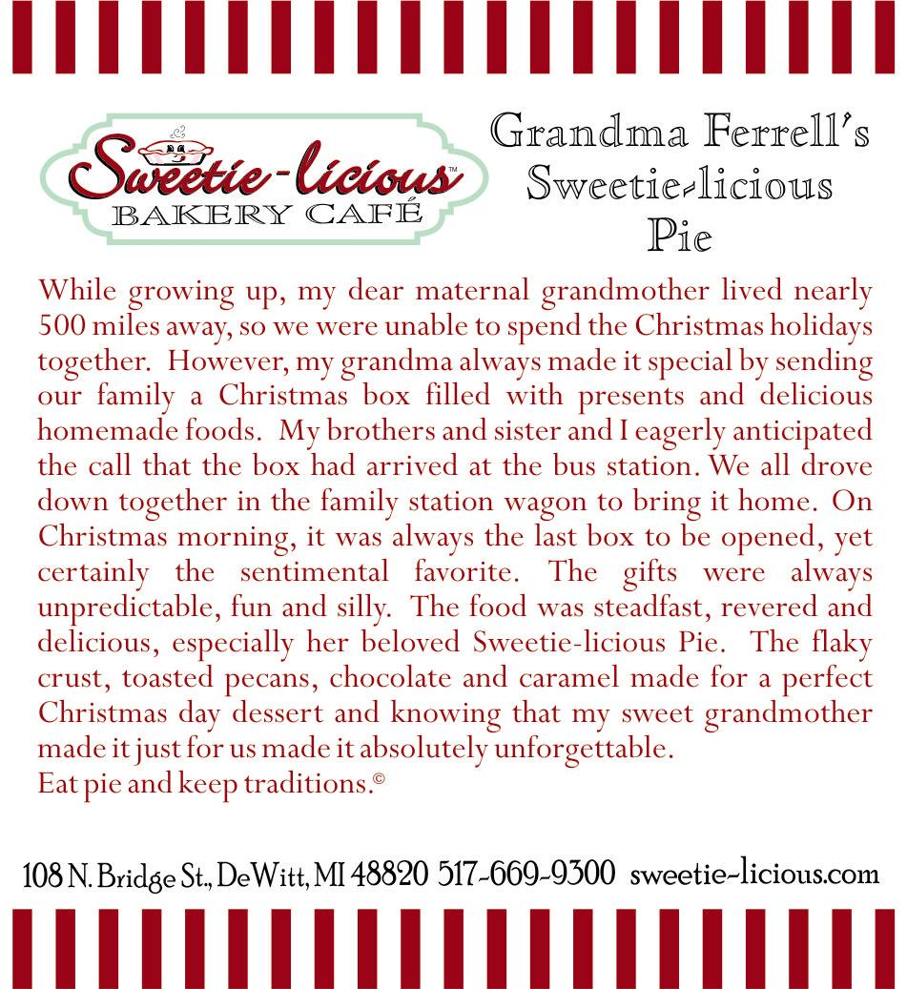

Christmas began in the heart of God.
It is complete only when it reaches the heart of man. Christmas is the day that holds all time together. -- Alexander Smith

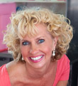
About Linda Hundt …
Linda resides in a century-old farmhouse with her sweet husband and two lovely daughters, when back from college. She is the owner of Sweetie-licious Bakery Cafe in DeWitt MI. Linda was the “Crisco Innovation” Grand Prize winner in 2011 and won Best-in-Show in 2009…she has won 16 first places at the National Pie Championships since 2007. Linda has appeared on the Food Network and on the Today Show with Willard Scott. Linda is the co-founder of the DeWitt Farmers Market, Board Member of the CMU Entrepreneurial School, a member of the msuENet board, and recipient of 2009 Athena Power-Link award.
108 North Bridge St. DeWitt, MI 48820
(517)669-9300 www.sweetie-licious.com

