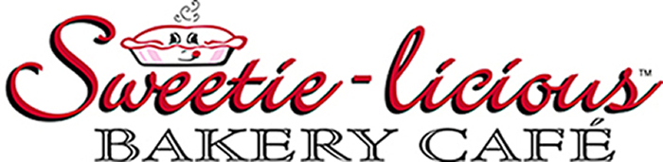

Sweetie-licious Bakery Café Wins Top Award from
Modern Baking Magazine

For Immediate Release
Contact: Linda Hundt
(517) 669-9300
DEWITT, MI (August 3, 2011) -- Sweetie-licious Bakery Café was one of only two bakeries across the country that received Modern Baking Magazine’s 2011 “Leadership Award for Merchandising”. Modern Baking is the most widely read professional publication that covers all aspects of the baking industry – retail/wholesale, supermarket baking, and food service baking. It reaches folks who bake for over 86,000 locations and includes features on successful operations, product news, and articles focused on trends affecting the industry.
The award-winning bakery won the award based on the vintage displays and retro store décor, as well as the pie packaging which includes a pie story attached to each pink pie box that goes out the door. Linda Hundt, owner of Sweetie-licious, was thrilled at receiving news of the win.
“I am tickled pink to win such a prestigious award! It is such an honor to be recognized as a national leader in the baking world,” Hundt said.
Linda and Sweetie-licious have won 15 first-place ribbons at the American Pie Council/Crisco National Pie Championships as well as winning the 2011 Crisco “Innovation Award” and Best-of-Show as part of the Food Network’s, “Amazing Pie Challenge” in 2009. She and/or her recipes have appeared in numerous other national magazines including Country Living, Midwest Living, American Profile, and Parade.
Sweetie-licious Bakery Café, the vintage-style destination bakery in downtown DeWitt, Michigan ships pies and baked goods throughout the country. Hundt is a nationally-recognized speaker and food television personality known for her inspirational pie wisdom, retro dresses and aprons. www.sweetie-licious.com

