
Sweetie News – Summer 2011

Good Food, Good Deeds Good Lives… by Linda Hundt

Welcome, welcome, welcome to our Sweetie-licious newsletter. Our mission is to celebrate home-life through stories of good food, good deeds, and good lives. Each issue will also include a delicious recipe. I’m thrilled to share my treasured library of recipes, stories and traditions with you all! So friends, here’s to making our lives meaningful, our homes happy, and our palates joyous!

I am completely convinced that our Michigan summers are the best summers anywhere. They are generally not too humid, not too cold with a just the right amount of sunshine to make picnics, days at
the beach, and backyard barbeques perfect pastimes.

Growing up with family picnics are some of my most treasured summer memories. It seemed like back then more people went on picnics. There were church picnics, company picnics, end-of-school picnics, reunion picnics, and family picnics. I remember back then, my mom would pack our picnic basket with a lovely spread, and we would go on a Sunday drive to an area park, mostly Potter Park, and enjoy our family dinner in a new, exciting venue! She usually had fried chicken, potato salad, cut melon, cold pork and beans out of a can (not a favorite) and a yummy dessert. Sometimes my mommy would pack a pie, but usually a brownie or a bar of some sort. I’ve included the wonderful blonde brownie recipe that Mom Hundt still make on Sundays and it’s very similar to the one Mom McComb used to pack on those wonderful Sunday picnics.

I am not sure why picnics have fallen out of favor,
but I implore us all to bring them back. Take your loved ones to a nearby park or beach with a basket full of yummy food they don’t ordinarily eat. When my family goes on Sunday beach picnics, I often just take various artisan cheeses, breads, crackers, special fruits, olives, cut veggies with dips and dessert of
course! I also love to pack special novelty ice cold drinks. It makes the picnic so special. They love the unconventional delicious lunch! It’s always about
the food, you know. ☺ There is nothing, nothing like Lake Michigan for the perfect picnic venue! To make your picnic extra special, remember to bring along a pie, if not your own, then of course, an award- winning, Sweetie-licious pie!
Eat Pie & Love Life… Linda

Mom Hundt’s & Mom
McComb’s Blondie Brownies
This is the perfect bar for any occasion, as it cuts wonderfully and is easy to store in plastic bags for packing purposes. Like any bar, be sure to not over-bake! You want to keep them yummy and moist.
1 1/4 C. flour
1/2 tsp. baking powder
1/8 tsp. baking soda
1/2 tsp. salt
1/2 C. chopped fine pecans or walnuts
1/4 C. chocolate chips
1/4 C. butterscotch chips
1/2 C. melted butter
1 C. brown sugar
1 egg
1 1/2 tsp. vanilla
Combine dry ingredients, cream together wet ingredients. Add dry ingredients to wet ingredients. Spread into one nine inch buttered pie pan. Bake at 350 degrees for 25 to 30 minutes. Cut in pie wedges.
2011 Crisco National
Pie Championships
We are once again, over the moon and back for our many wins at the 2011 American Pie Council Crisco National Pie Championships in Orlando, Florida! We won a total of four awards – Stephanie, our lead baker and I were elated that one of our favorites, Mommy’s Blackberry Raspberry pie won first place in the Berry category for Commercial Small Bakeries across the country. We again, were pleased as punch with our other Professional wins - First place in Open Category – Grandma & Mommy’s Pumpkin Caramel Apple Pie; Second place – The Farmette’s Blueberry Basil & Lime pie, and the biggie - Best in Show in the “Crisco’s 100 Year Anniversary Innovation Category” for Laura’s Sticky Toffee Pudding Caramel Apple Pie!

The Crisco Innovation 100 Year Anniversary Best of Show is such an honor to win! We won a great gift basket and trophy, $2000.00, and the coveted opportunity to have our recipe on the Crisco can! We are thrilled!

I cannot thank enough all our faithful customers that believe in what we do and the amazing team at the shop. A huge slice of gratitude to our sponsors, the Cherry Marketing Institute and Dandee Printing for their generous contributions to our trip down to Florida! We honestly couldn’t do it without all of you!
Sweetie News

Speaking of picnics, Sweetie-licious is having its
1st. annual Company Picnic for our hard-working employees this summer, and I am SO excited about it. We are using some of our Crisco Pie Championship prize money to fund it, and it will be just like the
company picnics of yesteryear. It warms my heart to
reward our amazing, hard-working staff with a day filled with fun, food, and friends!

We will be at the Meridian Farm Market every Saturday through the fall, selling our delicious muffins, cookies, pies, and jams for you all to enjoy!
Thanks to all of you for making this happen! We love having Sweetie-licious on the road…

Mail Order - As you may or may not know, our mail order is up-and-running, so you can send your favorite pies, cookies, & muffins to folks across the country. A big shout-out to Cheryl Kellogg & Laura Schmelter for all their hard work!

“Where Has Your Pie Been!?” - We know our pies travel all over during the summer… so remember to take a picture of our pink pie box and send it to us via Facebook to add to our collection of photos (which we post on our Website).

If you’re not a fan of Sweetie-licious on Facebook, please become one. We have daily news and menus, recipes, and Monday online specials for our fans to take advantage of!

Summer afternoon - summer afternoon; to me those have always been the two most beautiful words in the English language.
-- Henry James
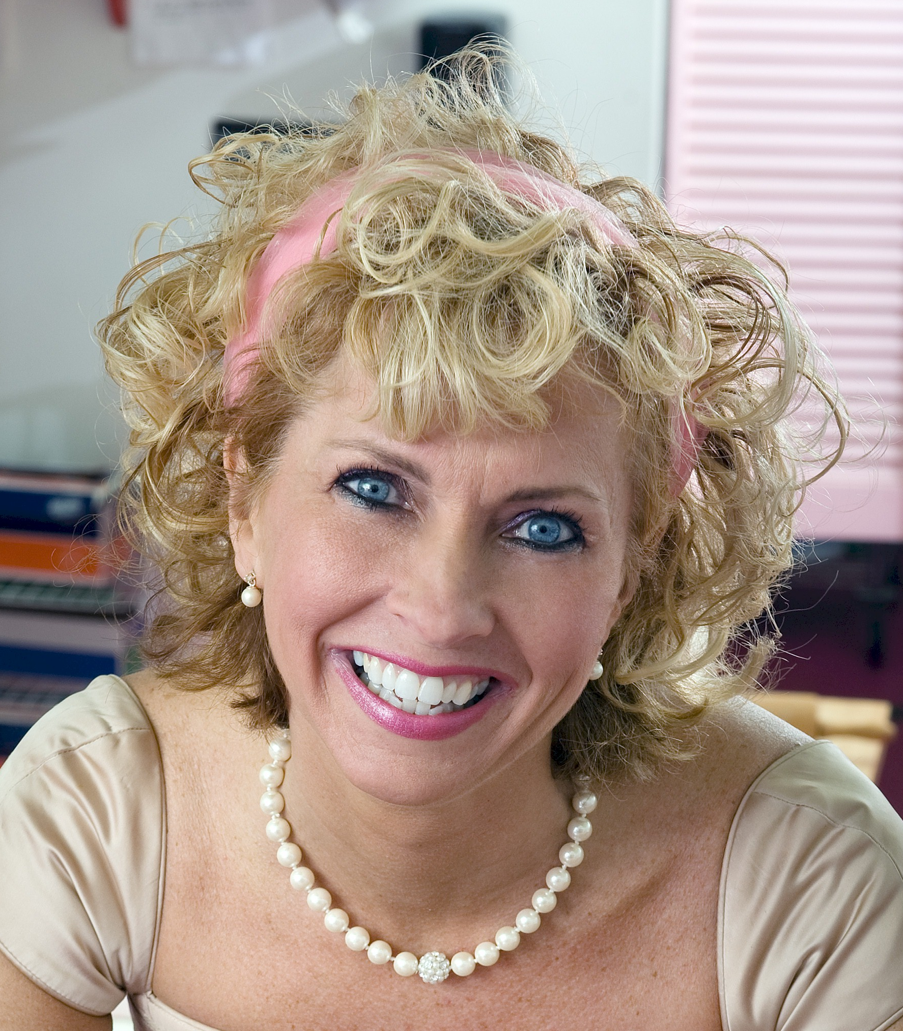
About Linda Hundt …
Linda resides in a century-old farmhouse with her sweet husband and two lovely daughters. She is the owner of Sweetie-licious Bakery Cafe in DeWitt MI. Linda was the “Crisco Innovation” Grand Prize winner in 2011 and won Best-in-Show in 2009…she was a first place winner in 2010, 2008,
& 2007 at the National Pie Championships. Linda has appeared on the Food Network and on the Today Show with Willard Scott. Linda is the co-founder of the DeWitt Farmers Market, Board Member of the CMU Entrepreneurial School, and recipient of 2009 Athena Power-Link award
108 North Bridge St. DeWitt, MI 48820
(517)669-9300 www.sweetie-licious.com

